UDC specify UDC index

TITLE

N. Surname (-s)
Full name of the organization, city, country
Abstract. Abstract text (100–150 words).
Keywords: list from 10 keywords (phrases) separated by semicolons.
Introduction
Text Text Text Text Text Text Text Text Text Text Text Text Text Text Text Text Text Text Text Text Text Text Text Text Text Text Text Text Text Text Text Text Text Text Text Text Text Text Text Text Text Text Text Text Text Text Text.
Main Part
Text Text Text Text Text Text Text Text Text Text Text Text Text Text Text Text Text Text Text Text Text Text Text Text Text Text Text Text Text Text Text Text Text Text Text Text Text Text Text Text Text Text Text Text Text Text Text.
An example of the figure design and the caption to it is presented below.

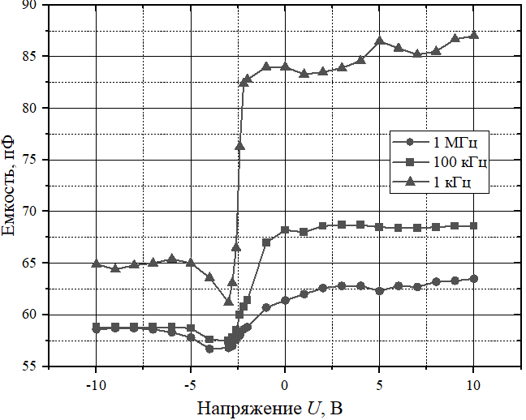 | 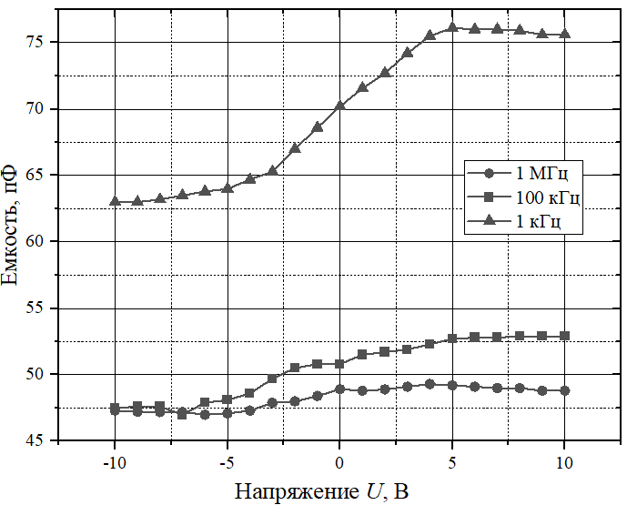
а b
Fig. 1. Figure capture: a – part a name; b – part b name

Examples of equation design are provided below (all equations must be typed in the MathType editor; Cyrillic and Greek characters, as well as numbers and functions, must be presented in equations in upright font, Latin characters must be presented in equations in italic font; font type – Times New Roman, 14 pt.; all equations must be numbered).
(1)
where W – text; s – text; …
An example of table design is presented below.

Table 1. Table name
Column 1 name | Column 2 name | Column 3 name
Text | Text | Text
Conclusion
Text Text Text Text Text Text Text Text Text Text Text Text Text Text Text Text Text Text Text Text Text Text Text Text Text Text Text Text Text Text Text Text Text Text Text Text Text Text Text Text Text Text Text Text Text Text Text
References
(should contain bibliographic descriptions of only scientific articles and books)
1. Reference 1.
2. Reference 2.
Information about the authors
Surname N., academic degree (for example, Dr. Sci. (Tech.), Cand. Sci. (Econ.)), academic rank (for example, Professor, Associate Professor), position (for example, Head of the Department, Head of Laboratory), full name of the organization, e-mail.

References list should be designed according to the examples presented below.

Feature | Example of the description
The paper has 6 authors or less and presented in Russian | Mironova A. L., Gavrilyuk E. Yu., Guslyakova A. V., Svalova A. S., Gonchar V. N. (2020) Application of Simulation Modeling Tools in Optimizing Business Processes. Economics and Management of the National Economy. (11), 49–53 (in Russian).
The paper has 6 authors or less and presented in English | Anand S., Burke E., Chen T., Clark J., Cohen M., Grieskamp W. (2020) An Orchestrated Survey on Automated Software Test Case Generation. Journal of Systems and Software. Elsevier. 40 (4), 540–560.
The paper has 6 authors or less and presented in Russian | Mironova A. L., Gavrilyuk E. Yu., Guslyakova A. V., Svalova A. S., Gonchar V. N., Zaitsev E. I., et al. (2020) Application  of Simulation Modeling Tools in Optimizing Business Processes. Economics and Management of the National Economy. 12 (10), 49–53 (in Russian).
The paper has more than 6 authors and presented  in English | Anand S., Burke E., Chen T., Clark J., Cohen M., Grieskamp W., et al. (2014) An Orchestrated Survey on Automated Software Test Case Generation. Journal of Systems and Software. Elsevier. C-39 (4), 582–586.
Book | Ivanov P. V., Dashkova I. A., Tkachenko I. V., Kostylev V. I. (2022) Methods of Making Management Decisions. Moscow, Yurait Publishing House (in Russian).

